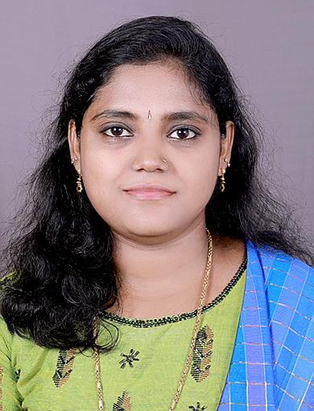 |  | Smisha M A
Contact  PHONE:  +91 9946560670  EMAIL:  smishaashok@gmail.com  Details  DoB: 11.04.1991  Sex: Female  Nationality: Indian  Official Address  Smisha M A  Assistant Professor  Department of Mathematics  St. Michael’s College, Cherthala  688524  REsidential Address  Ishaans  Kalavamkodam  Cherthala  688524 |  | EDUCATION  Doctor of Philosophy (Ph.D.) (2022)  From Cochin University of Science and Technology  Thesis: “Embedding of Amalgam of Some Class of  Γ-semigroups and Rees Matrix Semigroups”  Guide: Prof. (Dr.) P G Romeo, CSIR Emeritus Scientist  M.Sc. Mathematics (2013)  From Cochin University of Science and Technology  B.Sc. Mathematics (2011)  From Christ College, Irinjalakkuda, Thrissur  WORK EXPERIENCE  St. Michael’s College, Cherthala, Assistant Professor  13.10.2015 – ….  Carmel College, Mala, Assistant Professor on Contract  09.08.2013 – 31.03. 2014  CUSAT, School of Engineering, Assistant Professor on Contract  02.07.2013 – 08.08.2013  Publications  - P.G. Romeo, Smisha M A: Embedding of Rees Matrix Semigroup Amalgam, Proceedings of International Conference on Semigroup, Algebra and Applications, September 2015 pp: 31-41  - P.G. Romeo, Smisha M A: On matrix semigroups and matrix semigroup amalgams, International Journal of Research and Analytical Reviews, May 2019, Vol 6, Issue 2, 452-456  - P.G. Romeo, Smisha M A: On the embedding of Γ-semigroup amalgam, Malaya Journal of Mathematik, January 2021  - P.G. Romeo, Smisha M A: On the embedding of Γ-semigroup amalgam using partial Γ-groupoids, Advances in Algebra, June 2021  - P.G. Romeo, Smisha M A: Rees matrix semigroup over a Γ-semigroup, Bull. Cal. Math. Soc., 114, (2) 115–124 (2022)

